A Hands-on Demo on Arduino Programming

IEEE MVSR SB Circuits and Systems Society (CASS) conducted a two-day demo on Arduino programming. The main objective of this workshop was to deliver some basic information about usage of the Arduino board and programming using Embedded C.

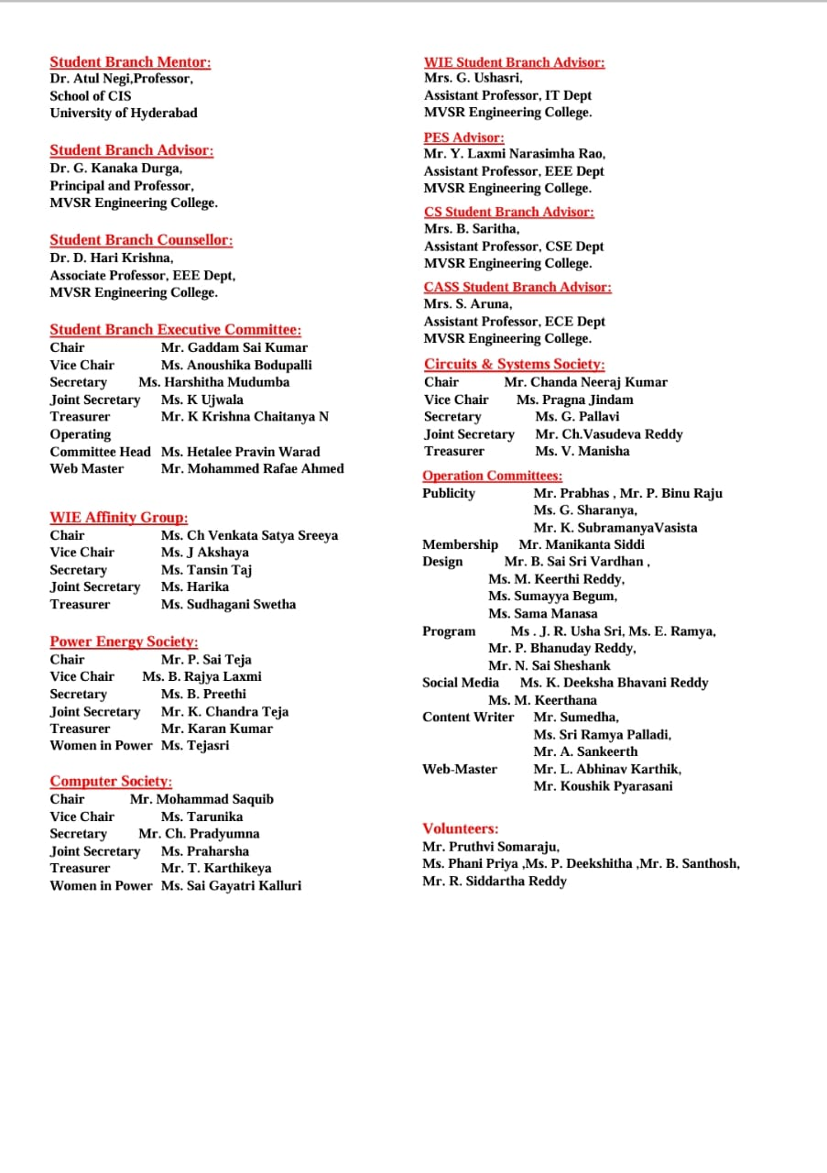

Session 1 Details:

Date: 8th December, 2023

Timings: 2:15PM – 4:15 PM

No. of Attendees: 51, IEEE : 9, NON-IEEE : 39

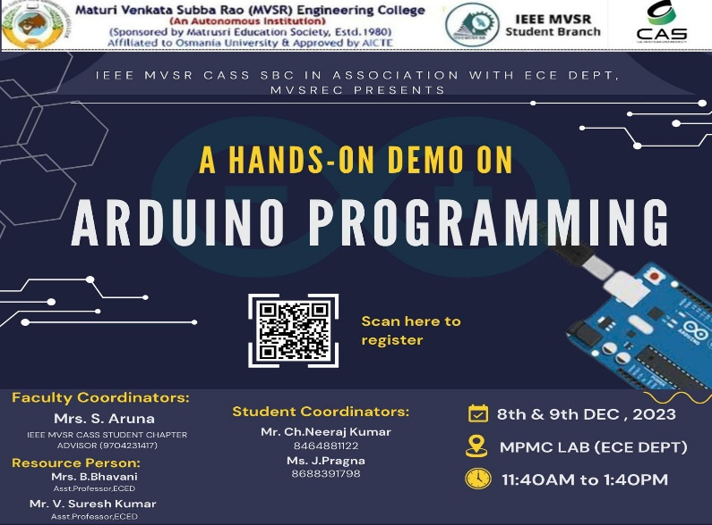
Poster

The workshop was commenced by Mrs. B. Bhavani, Asst. Professor ECE Dept. MVSR Engineering College with the assistance from Mrs. S. Aruna, IEEE MVSR SB, CASS Advisor. The trainer started the session with the introduction to Arduino. Later went on to give explanation how to use Arduino board, its pin description, Arduino IDE, data types, operators, control statements, loops, functions, strings, arrays, I/O functions.

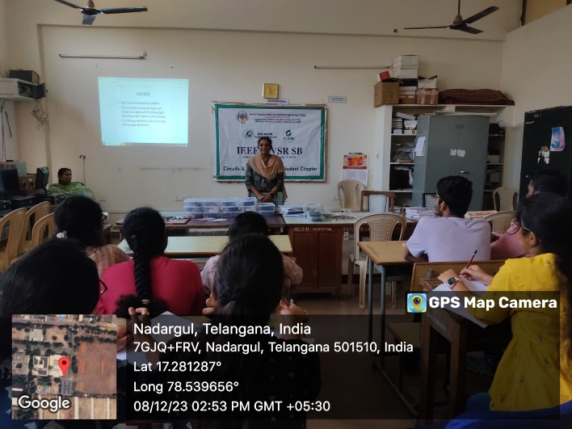
Speaker addressing the gathering on Day 1

With this knowledge the trainer also gave hands on experience by using LED’s and different sensors like humidity sensor, temperature sensor, water detector sensor, PIR sensor, ultrasonic sensor, switch interfacing etc.

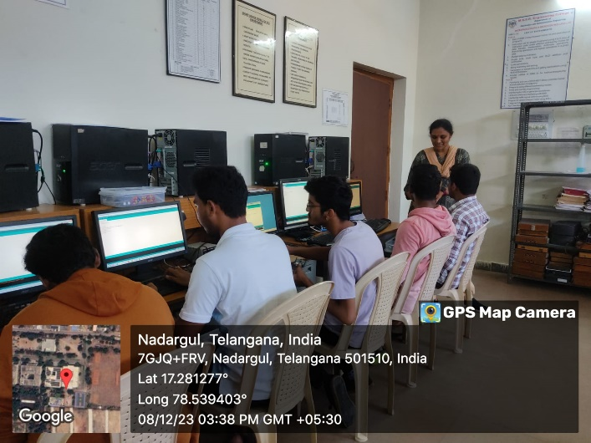
Participants with hands on experience

Session 2 Details:

Date: 9th December, 2023

Timings: 11:40 AM – 1:40 PM

The Day 2 of the session was commenced by Mr. V. Suresh Kumar, Asst. Professor, ECED by explaining the basic differences between Controller and Processor, 8086 microprocessor, 8051 microcontroller. Then, explicitly explained the schematic of Arduino UNO, Arduino Software, Programs structure.

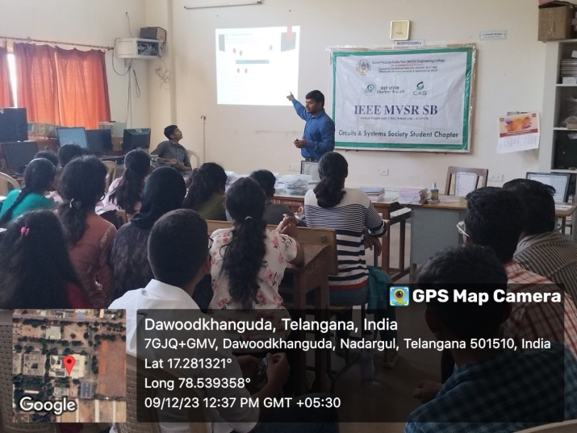
Speaker addressing the gathering on Day-2

Subsequently, elucidated the essential topics in Embedded C, including Datatypes, Functions, Loops etc. Thereafter, explained the working principles of Blinking LED. Fading LED, Humidity Sensor, Temperature Sensor, Water Detector Sensor and many more. The students had the opportunity to get hands-on experience with Arduino Boards and worked on projects involving Blinking LED, Ultrasonic Sensors. Following the session, the students expressed their satisfaction and provided positive feedback.

List of Attendees:

S.NO | Name of the Participant | Department | IEEE ID
1 | Chanda Neeraj Kumar | ECE | 98194538
2 | J Pragna | ECE | 98194494
3 | Siddi Manikanta | ECE | 99454271
4 | G Pallavi | ECE | 99295467
5 | Chintala Vasudev Reddy | ECE | 99469411
6 | Shashank Macharla | ECE | -
7 | Gundrati Likitha | ECE | -
8 | Nikhil Chitgopekar | ECE | 99230196
9 | Damagatla Srikanth | ME | -
10 | Kolupula Mahesh | ECE | -
11 | S Venugopal Reddy | ECE | -
12 | SURYADEVARA RENU PRIYA | ECE | 98194979
13 | S. Varun Sagar | ECE | -
14 | MOHAMMED DAWOOD | ECE | -
15 | Kante Sai Nithish | ECE | 99293289
16 | Jannu Sahithi | ECE | -
17 | CHIDDAMCHETTI AKSHITHA | ECE | -
18 | Boppidi Pravallika | ECE | -
19 | CHINTHAKUNTLA NIKITHA | ECE | -
20 | Sai Vishveshwar Rao Kodipelly | ECE | -
21 | Akkanapelly Ashwath | ECE | -
22 | Garlapati Bhavana | ECE | -
23 | A S V SHARATH | ECE | -
24 | SHAIK AALIYA UMAIMA | ECE | -
25 | Yallabandi lohitha | ECE | -
26 | Pandula Usha | ECE | -
27 | Ruthwik Turlapati | ECE | 99682871
28 | Waseem baba | ECE | -
29 | CHINTHAKUNTLA NIKITHA | ECE | -
30 | CHALLA SRI POOJA CHANDRA | ECE | -
31 | BANAVATH SANTHOSH KUMAR NAIK | ECE | -
32 | GODASU ABHINAYA MUDIRAJ | ECE | -
33 | ANNAPUREDDY YESHWANTH REDDY | ECE | -
34 | Jampula Sahithi | ECE | -
35 | Suha Taskeen | ECE | -
36 | Popuri venkata naga susmitha | ECE | -
37 | Mohd.Jahangeer Basha | ECE | -
38 | J VENKATESH | ECE | -
39 | Maroju Pavani | ECE | -
40 | Pole Varshitha Reddy | ECE | -
41 | M Swetha Madhavi | ECE | -
42 | MUDAVATH YASHWANTH | ECE | -
43 | POLAPALLY SRINIDHI | ECE | -
44 | S A K Pavan Kumar | ECE | -
45 | SAMPARA VENKATA ANJANA AISHWARYA SAHITHI | ECE | -
46 | Ritheesha Neeli | ECE | -
47 | K. Sai Poojitha | ECE | -
48 | Aderla Pranaydeep Reddy | ECE | -

Reported by:
IEEE MVSR SB

